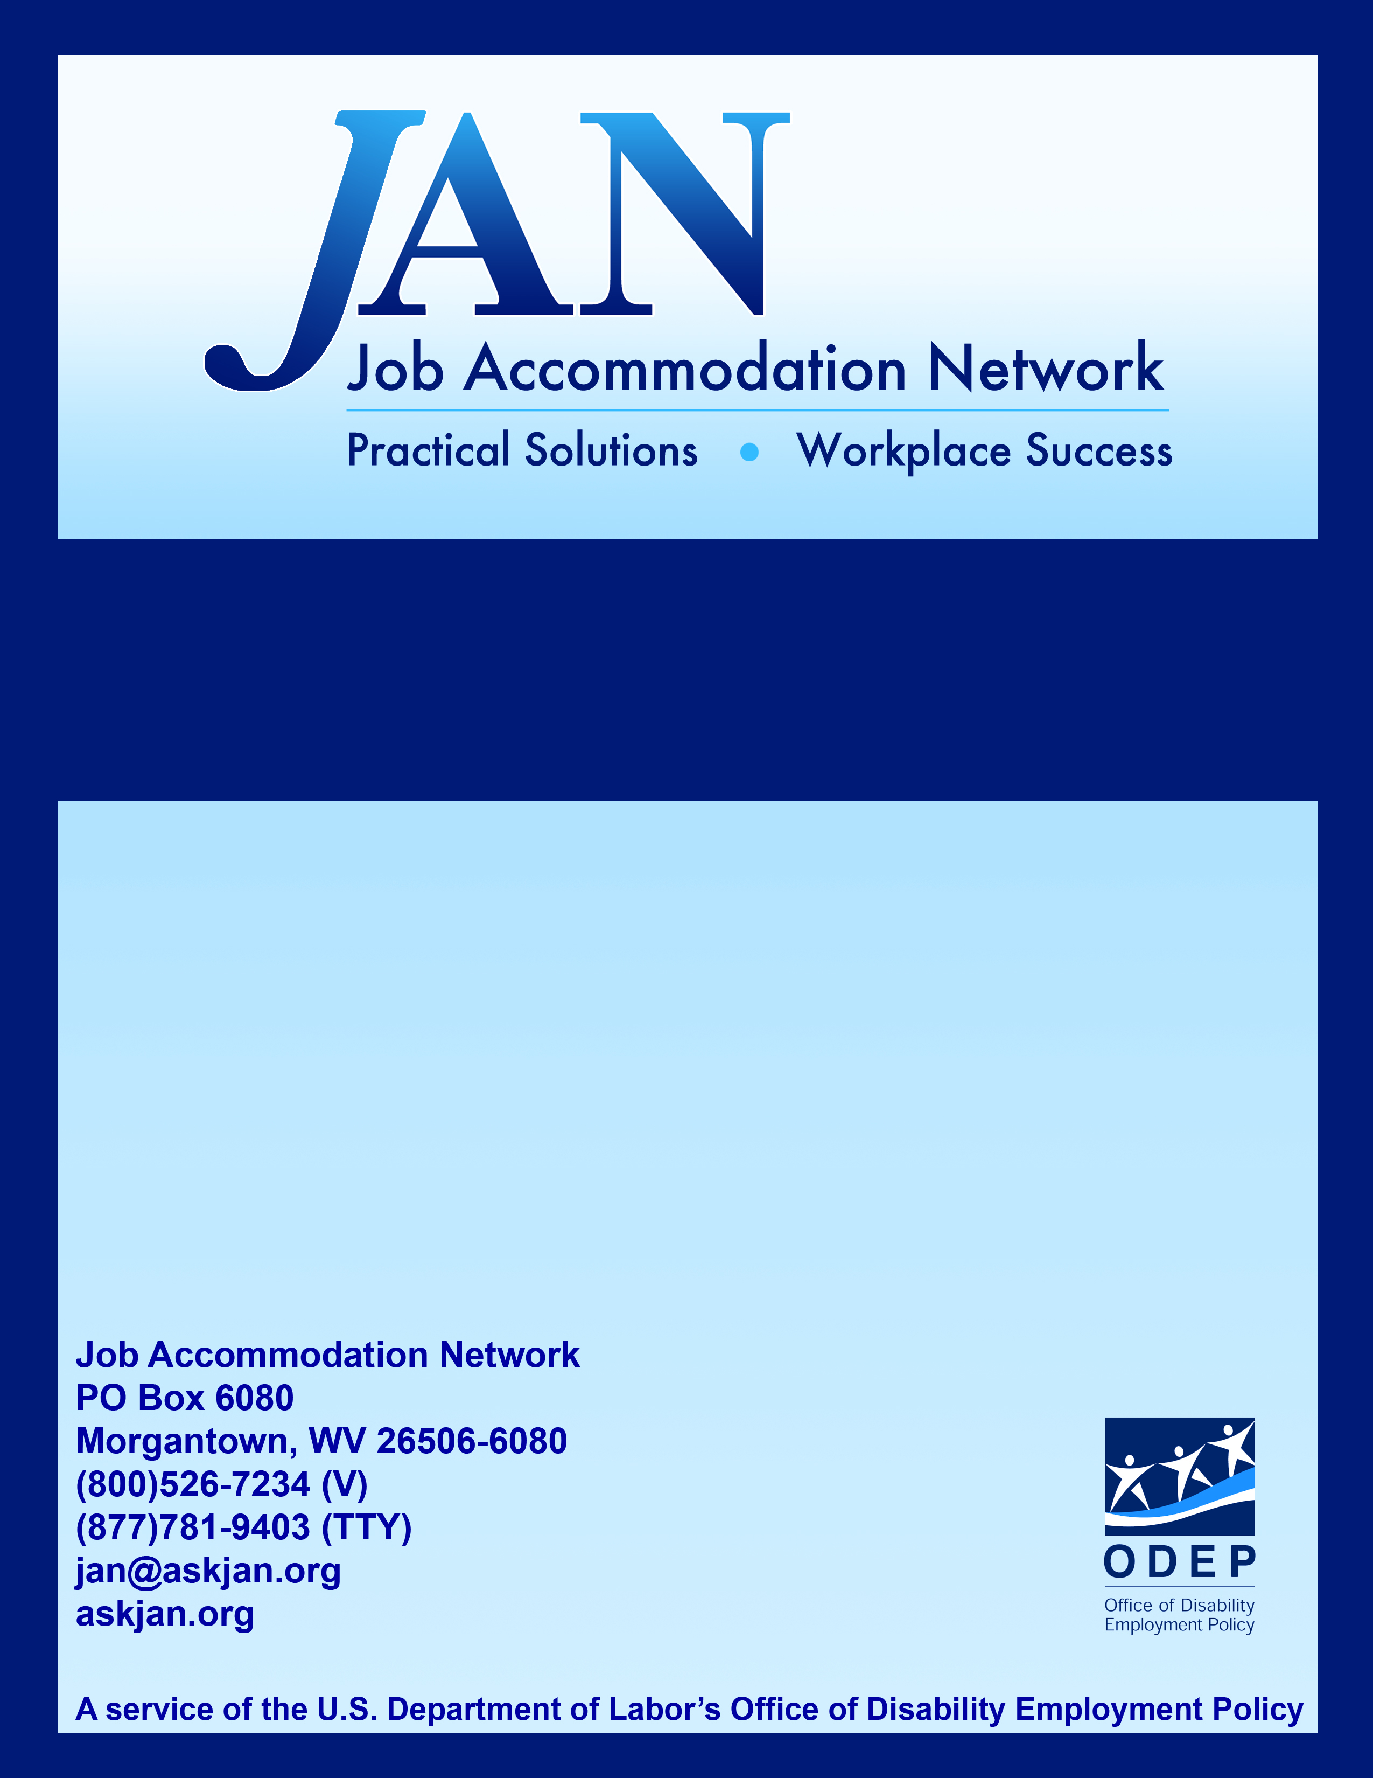
Job Accommodations for People with Autism Spectrum Disorders (ASD)

Fact Sheet Series

JAN’S ACCOMMODATION FACT SHEET SERIES

Job Accommodations for People
with Autism Spectrum Disorders

Autism Spectrum Disorders (ASDs), also referred to as Pervasive Developmental Disorders (PDDs), are brain-based developmental disabilities that affect a person’s ability to communicate, understand language, and relate to others. Estimates from the Centers for Disease Control and Prevention (CDC) indicate that 1.5 million Americans have ASD (Kennedy Kreiger Institute, 2005).

Adults with ASD, especially those with high-functioning Autism or with Asperger Syndrome, are able to work successfully in mainstream jobs (NIMH, 2009). Workplace limitations include: difficulties with social interaction, understanding social conventions, and social use of language (Kennedy Kreiger Institute, 2009).
This publication is a quick overview of some job accommodations that might be useful for employees with ASD. For more in-depth information, access JAN's publications at http://askjan.org/media/atoz.htm. To discuss an accommodation situation, contact JAN directly.
Exhibiting Acceptable Workplace Social Skills:
- Encourage all employees to model acceptable social skills
- Provide a job coach to help understand different social cues
- Recognize and reward acceptable behavior to reinforce such behaviors
- Review conduct policy with employee to reduce incidents of unacceptable behavior
- Provide concrete examples to explain unacceptable behavior
- Provide concrete examples to explain consequences
- Use training videos to demonstrate acceptable behavior in workplace
- Use role-play scenarios to demonstrate acceptable behavior in workplace
Interacting with Coworkers:
- Provide workplace sensitivity training to promote disability awareness
- Help employee "learn the ropes" by providing a mentor
- Make employee attendance at social functions optional
- Allow employee to transfer to another workgroup, shift, or department
- Encourage employees to minimize personal conversation, or move personal conversation away from work areas
- Provide telework, or work-at-home, as a job accommodation
- Allow alternative forms of communication between coworkers, such as email, instant messaging, or text messaging
Communicating Effectively with Supervisors:
- Provide detailed day-to-day guidance and feedback
- Identify areas of improvement for employee in a fair and consistent manner
- Provide clear expectations and the consequences of not meeting expectations
- Establish long term and short term goals for employee
- Assist employee in assigning priority to assignments
- Assign projects in a systematic and predictable manner
- Adjust supervisory method by modifying the manner in which conversations take place, meetings are conducted, or discipline is addressed
Communicating in the Workplace:
- Provide advance notice of meetings, particularly when employee is required to provide information to attendees
- Allow employee to provide written response in lieu of verbal response
- Provide advance notice of meeting topics, particularly when employee is required to participate verbally
- Allow employee to bring an advocate to performance reviews and disciplinary meetings
Resources

Job Accommodation Network
West Virginia University
PO Box 6080
Morgantown, WV 26506-6080
Toll Free: (800)526-7234
TTY: (877)781-9403
Fax: (304)293-5407
jan@askjan.org
http://AskJAN.org

Office of Disability Employment Policy
200 Constitution Avenue, NW, Room S-1303
Washington, DC 20210
Direct: (202)693-7880
TTY: (877)889-5627
Fax: (202)693-7888
infoODEP@dol.gov
http://www.dol.gov/odep/

Autistic Self Advocacy Network
PO Box 66122
Washington, DC 20035
info@autisticadvocacy.org
http://www.autisticadvocacy.org/

Autism Society of America
7910 Woodmont Avenue, Suite 300
Bethesda, MD 20814-3067
Toll Free: (800)3AU-TISM
Phone: (301)657-0881
info@autism-society.org
http://www.autism-society.org

Autism Speaks
2 Park Avenue, 11th Floor
New York, NY 10016
Direct: (212)252-8584
contactus@autismspeaks.org
http://www.autismspeaks.org

Daniel Jordan Fiddle Foundation
P.O. Box 1149
Ridgewood, NJ 07451-1149
Toll Free: (877)444-1149
Direct: (201)444-4141
Fax: (772)243-9847
http://www.djfiddlefoundation.org

National Autism Association
1330 W. Schatz Lane
Nixa, MO 65714
Direct: (877)622-2884
naa@nationalautism.org
http://www.nationalautismassociation.org

Organization for Autism Research
2000 N. 14th Street, Suite 710
Arlington, VA 22201
Direct: (703)243-9710
http://www.researchautism.org

Touch Point Autism Services
1101 Olivette Executive Parkway
St. Louis, MO 63132
Direct: (314)432-6200
info@touchpointautism.org
http://www.touchpointautism.org

Unlocking Autism
PO Box 208
Tyrone, GA 30290
Toll Free: (866)366-3361
http://unlockingautism.org

References

Kennedy Kreiger Institute. (2005). Autism spectrum disorders and pervasive developmental disorders, Retrieved April 7, 2009, from http://www.kennedykrieger.org/kki_diag.jsp?pid=1072
National Institute of Mental Health. (2009). Adults with an autism spectrum disorder. Retrieved April 7, 2009, from http://www.nimh.nih.gov/health/publications/autism/adults-with-an-autism-spectrum-disorder.shtml

Updated 9/28/11.

This document was developed by the Job Accommodation Network, funded by a contract agreement from the U.S. Department of Labor, Office of Disability Employment Policy (DOL079RP20426). The opinions expressed herein do not necessarily reflect the position or policy of the U.S. Department of Labor. Nor does mention of trade names, commercial products, or organizations imply endorsement by the U.S. Department of Labor.

